**CS 5551 Advanced Software Engineering**

**Smart Police**

Team 14

Gulnoza Khakimova

Pranitha Saroj Karumanchi

Sushma Sri Surapaneni

Sai Kalyan Vytla

Safety is a key feature in our life and it always is a priority while adding something new to our lives. The goal of this project is to create an application which will help police to find stolen cars by scanning license plates.

**Objectives**

The main goal of this application system is to provide the easy way to find the stolen car. Our app contains cameras which will scan the license plates either on the way or even in the parking slots and then it check whether it has any allegations or crime report active on that plate. Then, finally, it is reported to the police, which makes policemen job easy.

**Motivation**

If a car is stolen, user will log a complaint about the lost car in the police department. Police will update the stolen license number to the database. If any of car’s camera scans the license plate of the stolen car, then the user location is immediately sent to the police department if we could find an evidence of the stole car then the required action will be taken by the department. We would like to create an android application for this showing the login and signup pages in order to access their location.

**Significance**

Technology is evolving every day, so creating an interactive web application by reaching our goal within the time frame is our major objective. The key thing of the application is to provide the details of the theft cars and any other related cases on that car We personally take care in building a real-time system that is user-friendly and reachable to everyone and make sure it improves the security system. This app after scanning details of that plate it gives details like is that car theft.

**System Features**

In order to implement our application we will need to work on Android Studio and use different APIs which will help us to scan the license plate. We will be testing our application on real device with real products.

**References.**

**Prioritized Features:**

**Notifications**: Smart Police has this feature which enables police to get up information about stole car by scanning the license plate.

**Social media login:** Social media login is like a must and should, as many people are engaged in different social medias like facebook,twitter. So, enabling user to login with those accounts instead of creating a new account for this application.

**License plate scanning:** This is the key feature of this app, we will scan the license plate of different cars. and find whether is it in the recorded database. This make user to find his stolen car easily.

**API:** We use API to get better result. We call API which retrieve the information from database and shows to the user.

**Technologies**

**Android studio**: It is an official IDE. It is mainly used for application. It is a good editor tool where we can run over code and create UI according to our requirements. Here we are also using Gradle Plugin to run our code in different configuration. Our apk files can be easily moved to play store and can be edited. Using this we can check for performance , usability, by using lint tools. We are developing a android app, so this helps to support android wear apps.

**SCHEDULE FOR THREE DIFFERENT INCREMENTS**

We have finally proposed the project plan. Using the zenhub we have created the issues for our project. Project issues are divided as three increments. In the following, we gone show the work to improve in each increment.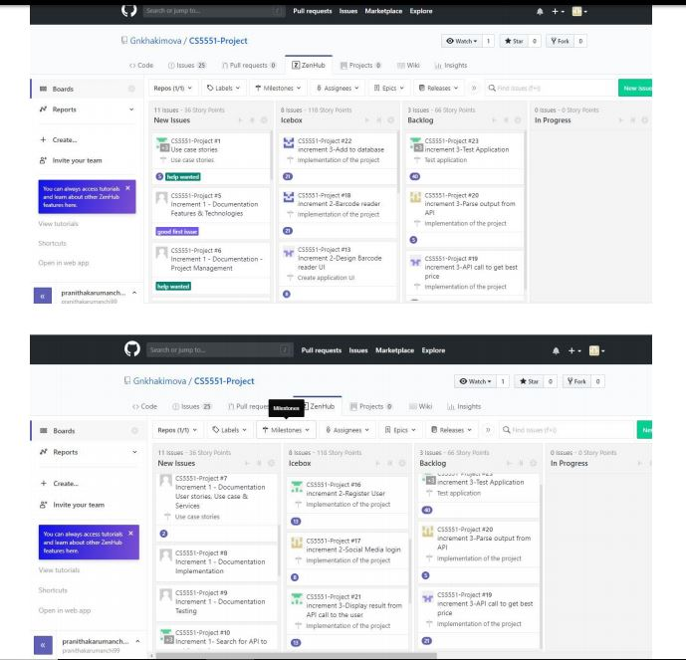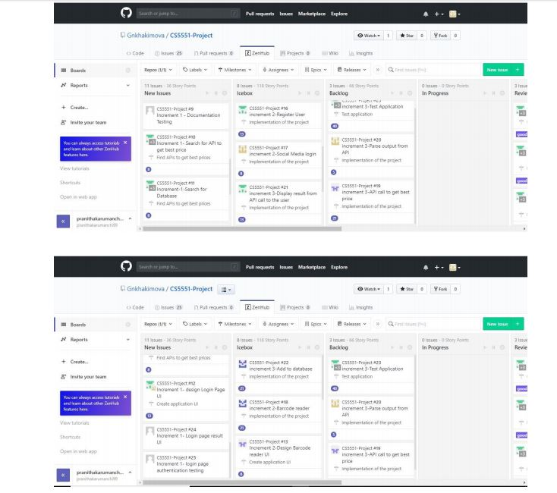

**Stories**

● As a user, they want to login, and scan license plate.

● We call API to get location.

● We display result from API call to the user.

● User can check the details of the stolen car.

● User can login through social media sites.

**Project TimeLines, Members, Task Responsibility**

We divided our project work into three incremental parts. In each phase every team member has there own roles in developing this app. Tasks were assigned to every member and reviewed at the end of the period. In zenhub we can see each others contribution.

Members of our group:

Gulnoza Khakimova

Pranitha Saroj Karumanchi

Sushma Sri Surapaneni

Sai Kalyan Vytla

**Task Responsibilities:**

Gulnoza Khakimova: Project proposal and issues.

Pranitha Saroj Karumanchi: Stories, project timelines,task responsibilities,burndown chart and issues.

Sushma Sri Surapaneni: Schedule plan.

Sai Kalyan Vytla: Project features and Technologies and issues.

**Burndown Chart**

